American Legion Auxiliary
Department President

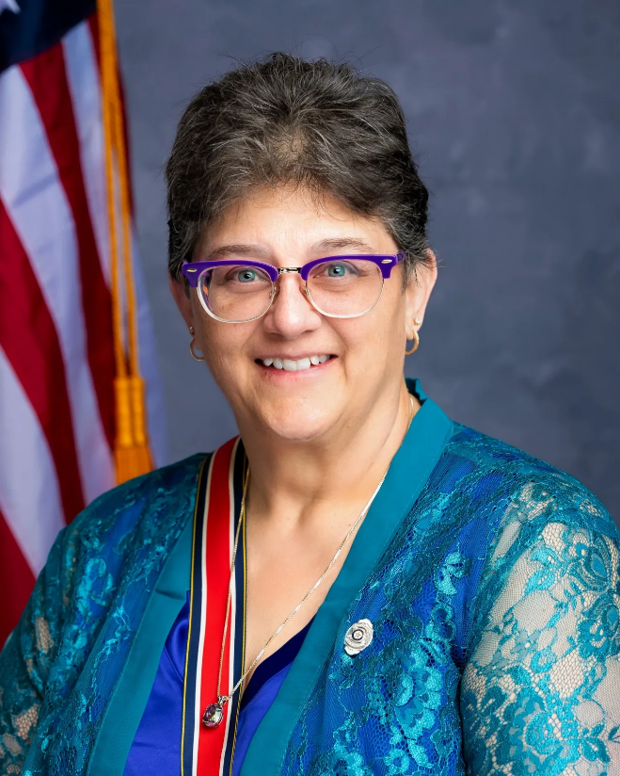

Kim Dixon
Oskaloosa Unit #0034

“Family No one Forgotten
no one left behind.”

American Legion Auxiliary
Central Division Vice President

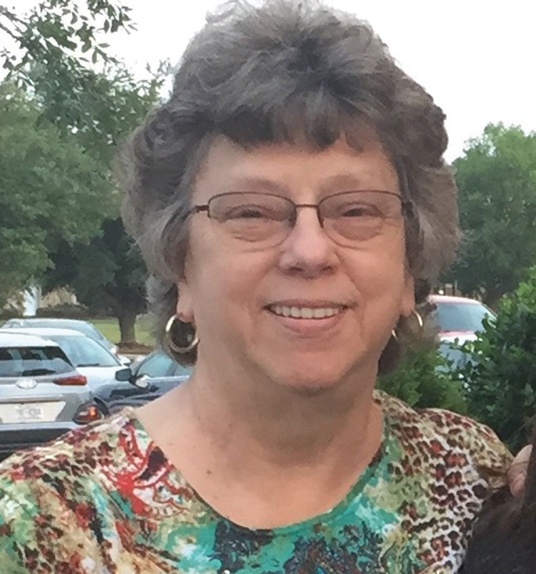

Ann Buchanan
Department of West Virginia

American Legion Auxiliary of Iowa
105th Department Convention

Holiday Inn Des Moines-Airport/Conférence Center
Des Moines, Iowa – July 17, 18 & 19, 2026

Thursday - July 16, 2026

REGISTRATION- BALLROOM FOYER - 10:30 a.m. – 2 p.m.

1:00 p.m. Finance Meeting – Iowa C
2:00 p.m. Governing Documents Meeting – Iowa C
6:00 p.m. Past Department Presidents’ Dinner

Friday - July 17, 2026

Registration – Ballroom Foyer – 12:00 – 2:30 pm & 5:00 – 7:00 pm
$10.00 All attendees except Juniors

8:30 a.m. Planning Meeting – Room 397
9:00 a.m. Department Executive Committee Meeting – Room 397
11:00 a.m. Installation Practice – Ballroom A

1:00 p.m. Page’s Practice – Ballroom A
2:00 p.m. Processional Line-up – Ballroom A
2:15 p.m. Call to Order Auxiliary General Session – Ballroom A

Processional
Chairman of Pages Patti Rolf
Assistant Chairman of Pages Regina Chock
McLaughlin Colors Mary Echelberger, Stacy Bane
Clapp Colors Carol Mooney, Cheyenne McDaniel

Pages First Jan Carlton Andrea Smith
Second Teresa Kramer Marlene Mertens
Third Joann Klein Rebecca Gimzo
Fourth Alma Meyer Janice Meyer
Fifth Tammi Quinlan Diane Shaffer
Sixth Rebecca Teed Sherry Rynearson
Seventh Beth Holton Michelle Higgins
Eighth Debra Copeland Amanda Meyer
Ninth Jackie Westover Kayla Wigand

District Presidents and Department Officers
Executive Director Page Patti Rolf
President’s Page Regina Chock

Invocation Dawn Aberle
POW/MIA Flag Leah Campbell
Moment of Silence
Pledge of Allegiance Marlene Mertens
The Star-Spangled Banner Marlene Mertens
The Preamble to the Constitution of the ALA Sandy Deacon
Call to Department Convention Crystal Wright
Credentials Crystal Wright
Convention Rules Ann Crawford
Finance Regina Chock
Patti Rolf, Ann Crawford
1st Reading of Governing Documents Sandy Deacon
Nominations Committee Jackie Tyne, Pam Clark, Rhonda Russell
National Executive Committee Member Report Kelly Elliott
Americanism Marlene Mertens
Community Service Cheyenne McDaniel
Poppy Linda Lux
Marketing Jamie Barker, Carol Mooney, Teresa Shaw
Chaplain Dawn Aberle
Historian Alida Kolthoff
Announcements Crystal Wright

Recess Auxiliary General Session until Saturday

7:00 p.m. Joint Session – Ballroom
TBA

Saturday - JULY 18, 2026

Registration – Ballroom Foyer – 8:00 – 8:30

8:30 a.m. Reconvene Auxiliary General Session – Ballroom A
Invocation Dawn Aberle
Pledge of Allegiance Judy Ring
Auxiliary Emergency Fund Rosemary Lancaster
Be The One Sherri Rosener
National Security Paige Copple
Veterans Affairs and Rehabilitation Judy Ring
Service to Veterans Stacy Bane
Education Shelley Conover
Kelly Elliott, Randie Gist, Merit Award Judges
Children & Youth Lily McClelland
Leadership Judy Ring
Department Member of the Year Judy Ring
Membership Team Jacki Bolen, Teresa Kramer, Rhonda Russell
Memorial Service Dawn Aberle

10:45-11:30 a.m. Auxiliary District Caucuses & Election
Election Polls are open from 10:45 to 11:30 a.m.
First District Room Iowa C
Second District Room 398
Third District Room 397
Fourth District Room Iowa B
Fifth District Room 292
Sixth District Room Iowa A
Seventh District Room 396
Eighth District Room Westview CS
Ninth District Room Westview N

1:00 p.m. Reconvene Auxiliary General Session – Ballroom A
Governing Documents - 2nd Reading & Resolutions Sandy Deacon
Risk and Compliance Jamie Barker, Verlinda Prior, Dawn Aberle
Girls State Bev Copple
Ann Rehbein, Michele Long, Danielle Propst Members
Junior Activities Alyssa Sparrgrove
Junior President Leah Campbell
Junior Camp Doris Jackson
Michelle Copple, Vickie Klinkhammer, Elaine Brookins
Registration Report Crystal Wright
Ratification of District Presidents and Vice Presidents, Crystal Wright
Call to National Convention Crystal Wright
Ratification of National Convention Delegates and Alternates Crystal Wright
Announcements Crystal Wright
President’s Report Kim Dixon
Election Results Kim Dixon
Introduction of 2026-2027 Department Officers Kim Dixon
Receiving Line of 2026-2027 Department Officers – No Receiving Line.
Recess Auxiliary General Session until Sunday
5:00 p.m. Color Guard Contest – Ballroom South
7:00 p.m. Iowa Veterans Band Concert – Iowa A

Sunday – July 19, 2026

8:00 a.m. Memorial Service – Ballroom North, Central and South

8:30 a.m. ALA Individual Photos Start– Iowa D
Executive Director
Department President
Department Vice President
Junior President
Chaplain and Historian
National Officers
9 District Presidents

8:45 a.m. ALA Group Photos Begin – Iowa D
2026 Department Convention Pages
2025-2026 Committee Chairmen/Members
2026-2027 Department Executive Committee
ALL Past Department Presidents

9:30 a.m. Installation of the 2026-2027 Department Officers and District Presidents

First District Liberty Smith
Second District Pamela Persson
Third District Laurel Degelau
Fourth District Carrie Chesmore
Fifth District Annette Roe
Sixth District Sherri Rosener
Seventh District LuAnn Armstrong
Eighth District Donna Jensen
Ninth District Shelley Conover

Retirement of POW/MIA Flag, Adjournment, Retirement of Colors, and Close of Convention.

11:00 a.m. Following Installation – 2026-2027 Department Executive Committee Meeting (Includes 2026-2027 Department Officers, 2026-2027 District Presidents, and Past Department Presidents on the Department Executive Board) in Iowa E Room.

American Legion Auxiliary
Photographs

Photograph order forms are available at www.timmcconnellphotography.com. The deadline is August 1, 2026. No orders will be accepted at the Department Office.

American Legion Auxiliary
Convention Committees

Convention Committee Ann Crawford, Mary Jo McLaughlin
Distinguished Guests Michele Long, Verlinda Prior

Pianist Sue Schlitter
Credentials Alison Perdue, Chairman

Please note: You must be a paid and registered delegate to vote, and your name tag must be worn at all times during Auxiliary sessions and voting. Alternates and guests are to sit in the back of the meeting room.

